|  |  |
| --- | --- |
| TEAM LEAD | NITHYA ASHWINI S |
| TEAM MEMBER 1 | LAKSHMI SINDHIYA S |
| TEAM MEMBER 2 | MONISHA E |
| TEAM MEMBER 3 | SUSHMITHA S |

PROJECT TITLE:

PERSONAL EXPENSES TRACKER

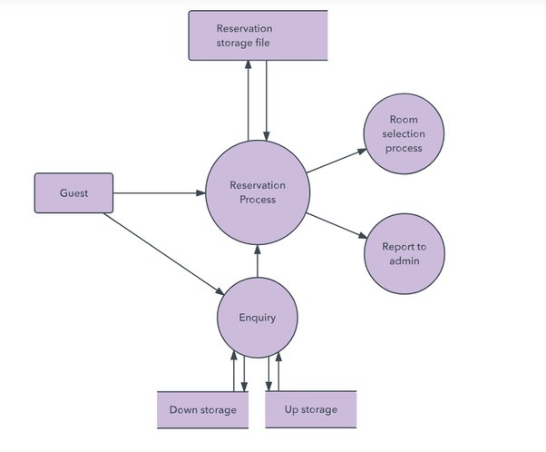

ANALYTICS

AND

INSIGHTS

RECURRING

BILLS

OFFERING

PRECISE

ANALYTICS

BUDGET VS ACTUAL SPENT